# User manual for application PhotoSharing

|  |  |
| --- | --- |
| After you have dowloaded and installed PhotoShare application, start it by clicking on its icon. When the application starts, you will see a somewhat similiar view open up as in Figure 1. At first, you problably don’t have any image loaded to your application, but don’t worry, by following our „How to“ guide, you will learn how it all works. | C:\Users\Siim\Desktop\Kool\Mobiilirakenduste loomine\PildiRakendus\mainpanel.png  Figure 1 |
| How to load your album to the application?  1. Click on the „Select Album“ button. 2. A list opens that contains your albums 3. Select the album you want to import 4. Selected album will be imported to the application’s list of pictures  How to take and add your own captured photo to the list?  1. Click on the „Take Picture“ button 2. You will now be forwarded to Androids Camera 3. Take your Picture 4. Your picture will now appear in the Picture list | C:\Users\Siim\Desktop\Kool\Mobiilirakenduste loomine\PildiRakendus\selectalbum.png  Figure 2 |
|  |  |
| How to open application’s main menu?  1. Select- Hold on the image that you would like to work with 2. Menu will appear as in Figure 3  How to delete an image?  1. Click-hold on the image to open up Main Menu 2. Select „Delete“ 3. Image will now be deleted | C:\Users\Siim\Desktop\Kool\Mobiilirakenduste loomine\PildiRakendus\menu.png  Figure 3 |
| How to start editing selected image?  1. Click-Hold on selected image until the Main Menu appears 2. Select „Edit“ 3. Photo Editor Panel will appear(as in Figure 4) 4. To get back to the Main panel, click on Androids Back button | C:\Users\Siim\Desktop\Kool\Mobiilirakenduste loomine\PildiRakendus\editorview.png  Figure 4 |
| How to edit image in Photo Editor  1. Click-Hold on the Picture 2. Menu with possible choices will appear(Figure 5) 3. Select prefered option from the list 4. The picture will be now changed according to your choice 5. If you choose to change brightness two buttons will appear 6. + button to increase brightness 7. – button to decrease brightness  How to save edited image?  1. Click-Hold on the image in the Photo Editor view 2. Choose „Save“(Figure 6)   Image will now be saved and appear on you picture list. | C:\Users\Siim\Desktop\Kool\Mobiilirakenduste loomine\PildiRakendus\edit options.png  Figure 5 |
| How to send image?  1. Click-Hold on the image you would like to send 2. Select „Send“ 3. Menu will appear(Figure 7) 4. You now have multiple choice how and where to send your image  Upload your image to a Social Network site  1. Select preferred site 2. Log in to your account 3. Post it | C:\Users\Siim\Desktop\Kool\Mobiilirakenduste loomine\PildiRakendus\sendtointernet.png |
|  | Figure 7 |
| How to send your image to another device? **If your phone doesn’t support Bluetooth, this cannot be done  **If your phone has Bluetooth turned off, you will be asked whether you would like to turn your Bluetooth on. Answer "Yes""   1. Select “Bluetooth“ from the list 2. Select „Scan for devices“(Figure 8) 3. Wait few seconds for your phone to scan for other devices in range. 4. Select the device you you would like to send the image to 5. Wait while the other phone is downloading the image | C:\Users\Siim\Desktop\Kool\Mobiilirakenduste loomine\PildiRakendus\scanned connection.png  Figure 8 |

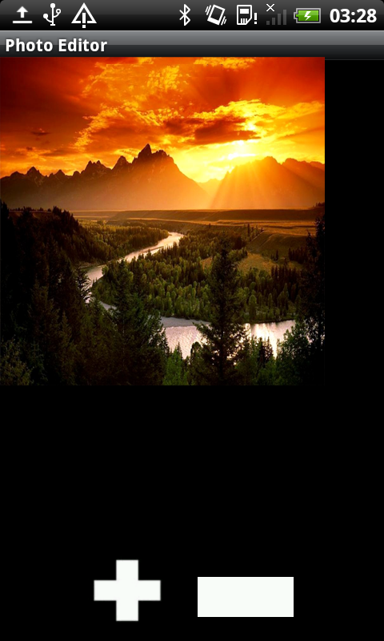

Figure 9